Revision History
Version | Date | Description | Written By
1.0 | Dec. 30, 2022 |  | DS Kim

Contents
- ArgosVue Specifications 3
- ArgosVue ROS Topic List 3
- Starting ArgosVue Camera System 3
- Visualizing ArgosVue’s Data with Rviz 4
- Configurable ArgosVue’s Parameters 5
- Setting Up ArgosVue’s Network 6
- Resetting ArgosVue Camera System 9
- Recalibrating ArgosVue Camera System 10

- ArgosVue Specifications
Field of View | 240 degrees (H) x 160 degrees (V)
Resolution | 1200 x 800 (Max 1680 x 1120)
Depth Range | 0.3 ~ 7.0m
Depth Accuracy | 1% @1.0m, 5% @5.0m
Frame Rate | 15 fps (@1200 x 800)

- ArgosVue ROS Topic List
Topic | Description | ROS Data Type
/argosvue/equimage0 | Color image of camera 0 | Image
/argosvue/equimage1 | Color image of camera 1 | Image
/argosvue/depthmap | Depth map (units are in millimeters) | Image
/argosvue/pointcloud | Point cloud | Pointcloud2

- Starting ArgosVue Camera System
- Execute the following command at a terminal to start the camera system
$ roslaunch argosvue stereo.launch
- username: argos
- password: qlwjs

- You can reset the camera system by executing the following commands when the camera system doesn’t work properly.

$ sudo systemctl restart nvargus-daemon.service

- Visualizing ArgosVue’s Data with Rviz
- Run the rviz with the provided rviz configuration file.

$ rviz -d argosvue.rviz

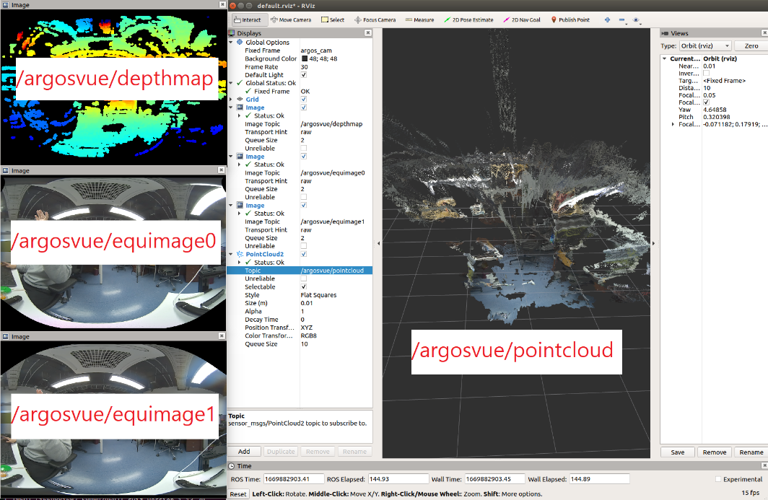

- Configurable ArgosVue’s Parameters
- You can configure your ArgosVue by modifying parameters in the following file with your editor (i.e. vim).

/home/argos/catkin_argosvue/src/argosvue/conf/settings.json
 | Parameter | Description | Default
params | fov | Horizontal and vertical field of view (in degrees) | 240, 160
 | pixel_per_degree | Pixels per degree (1~7) | 5
funcs | detect_short_range | Enable near-range depth calculation. (0: min 0.5m, 1: min 0.2m)  * System will be slow down when it is enabled. | 0
ROS_outputs | output_image0 | Enable publishing topic /argosvue/equimage0 | 1
 | output_image1 | Enable publishing topic /argosvue/equimage1 | 0
 | output_depthmap | Enable publishing topic /argosvue/depthmap | 1
 | output_pointcloud | Enable publishing topic /argosvue/pointcloud | 1
 | output_colored | Enable publishing depthmap and pointcloud in color (1: color, 0: mono)  * System will be slow down when it is enabled. | 0

- Camera system should be restarted after modifying the parameters.

$ roslaunch argosvue stereo.launch

- Setting Up ArgosVue’s Network

IP address configuration
- Set IP address of your system to 192.168.1.100

Network Edit Connection add a new connection select ethernet IPv4 setting Method: Manual Add

Address : 192.168.1.100, NetMask : 255.255.255.0

Save

You can check the setting by executing the following command in a terminal.

$ ifconfig eth0

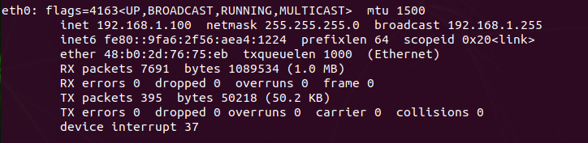
- Execute the following command to setup environment variables of terminal:
$ echo “export ROS_MASTER_URI=http://192.168.1.100:11311” >> ~/.bashrc
$ echo “export ROS_IP=192.168.1.100” >> ~/.bashrc
$ source ~/.bashrc

The following lines will be added to your .bashrc file:

If you want to use an IP address other than 192.168.1.100, you have to change the IP address in /home/argos/ArgosVue_ROS_env/ROS_env_setting.sh file.
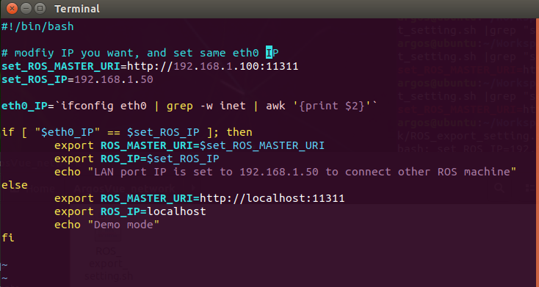

- Start “roscore” in a terminal
$ roscore

- Connect your ROS1 system to ArgosVue with a LAN cable.

- Connect to ArgosVue with SSH.
$ ssh argos@192.168.1.50
password: qlwjs

- Start your ArgosVue
- $ roslaunch argosvue stereo.launch

- You can check if ArgosVue outputs images properly by listing ROS Topics or executing rviz.

$ rostopic list

- You can check the network connection from the top bar.
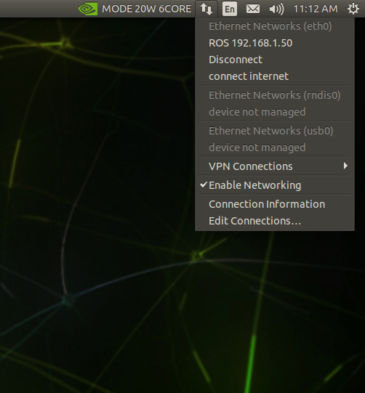

- Resetting ArgosVue Camera System
- If your camera system doesn’t work properly, you can reset the camera system without rebooting using the following commands:
$ sudo systemctl restart nvargus-daemon.service

$ roslaunch argosvue stereo.launch

